**Cloud Computing**

**Assignment 1**

|  |  |  |  |
| --- | --- | --- | --- |
| Vanshika Goel | PES1UG20CS484 | Section H | Roll No 40 |

**1a**

**1b**

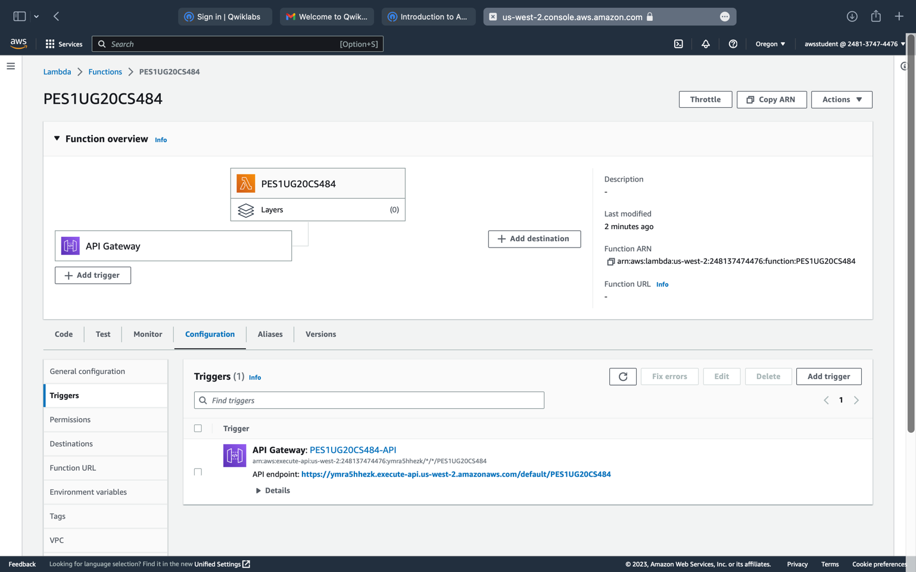

**1c**

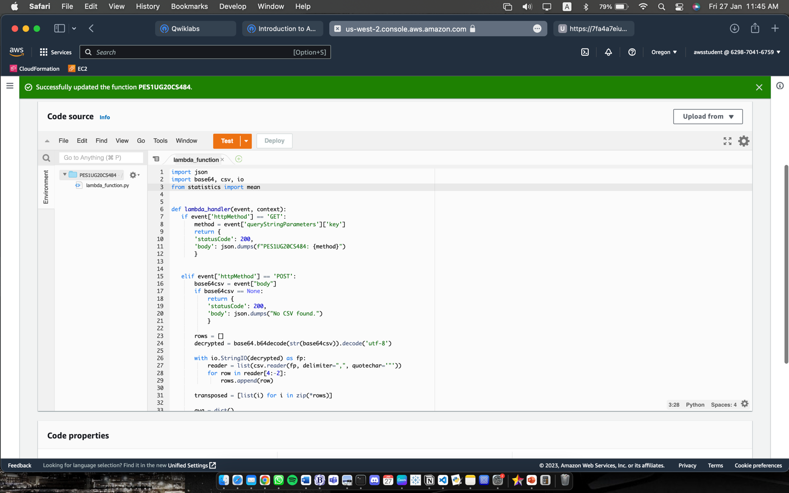

**1d**

**1e**

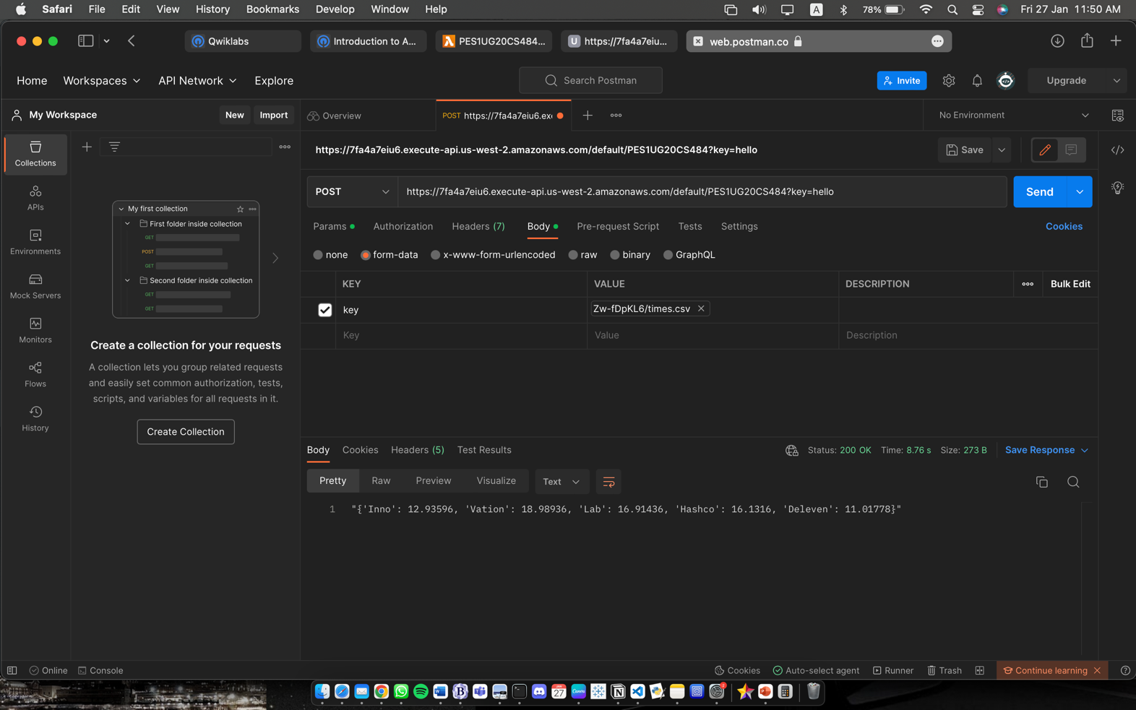

**1f**

